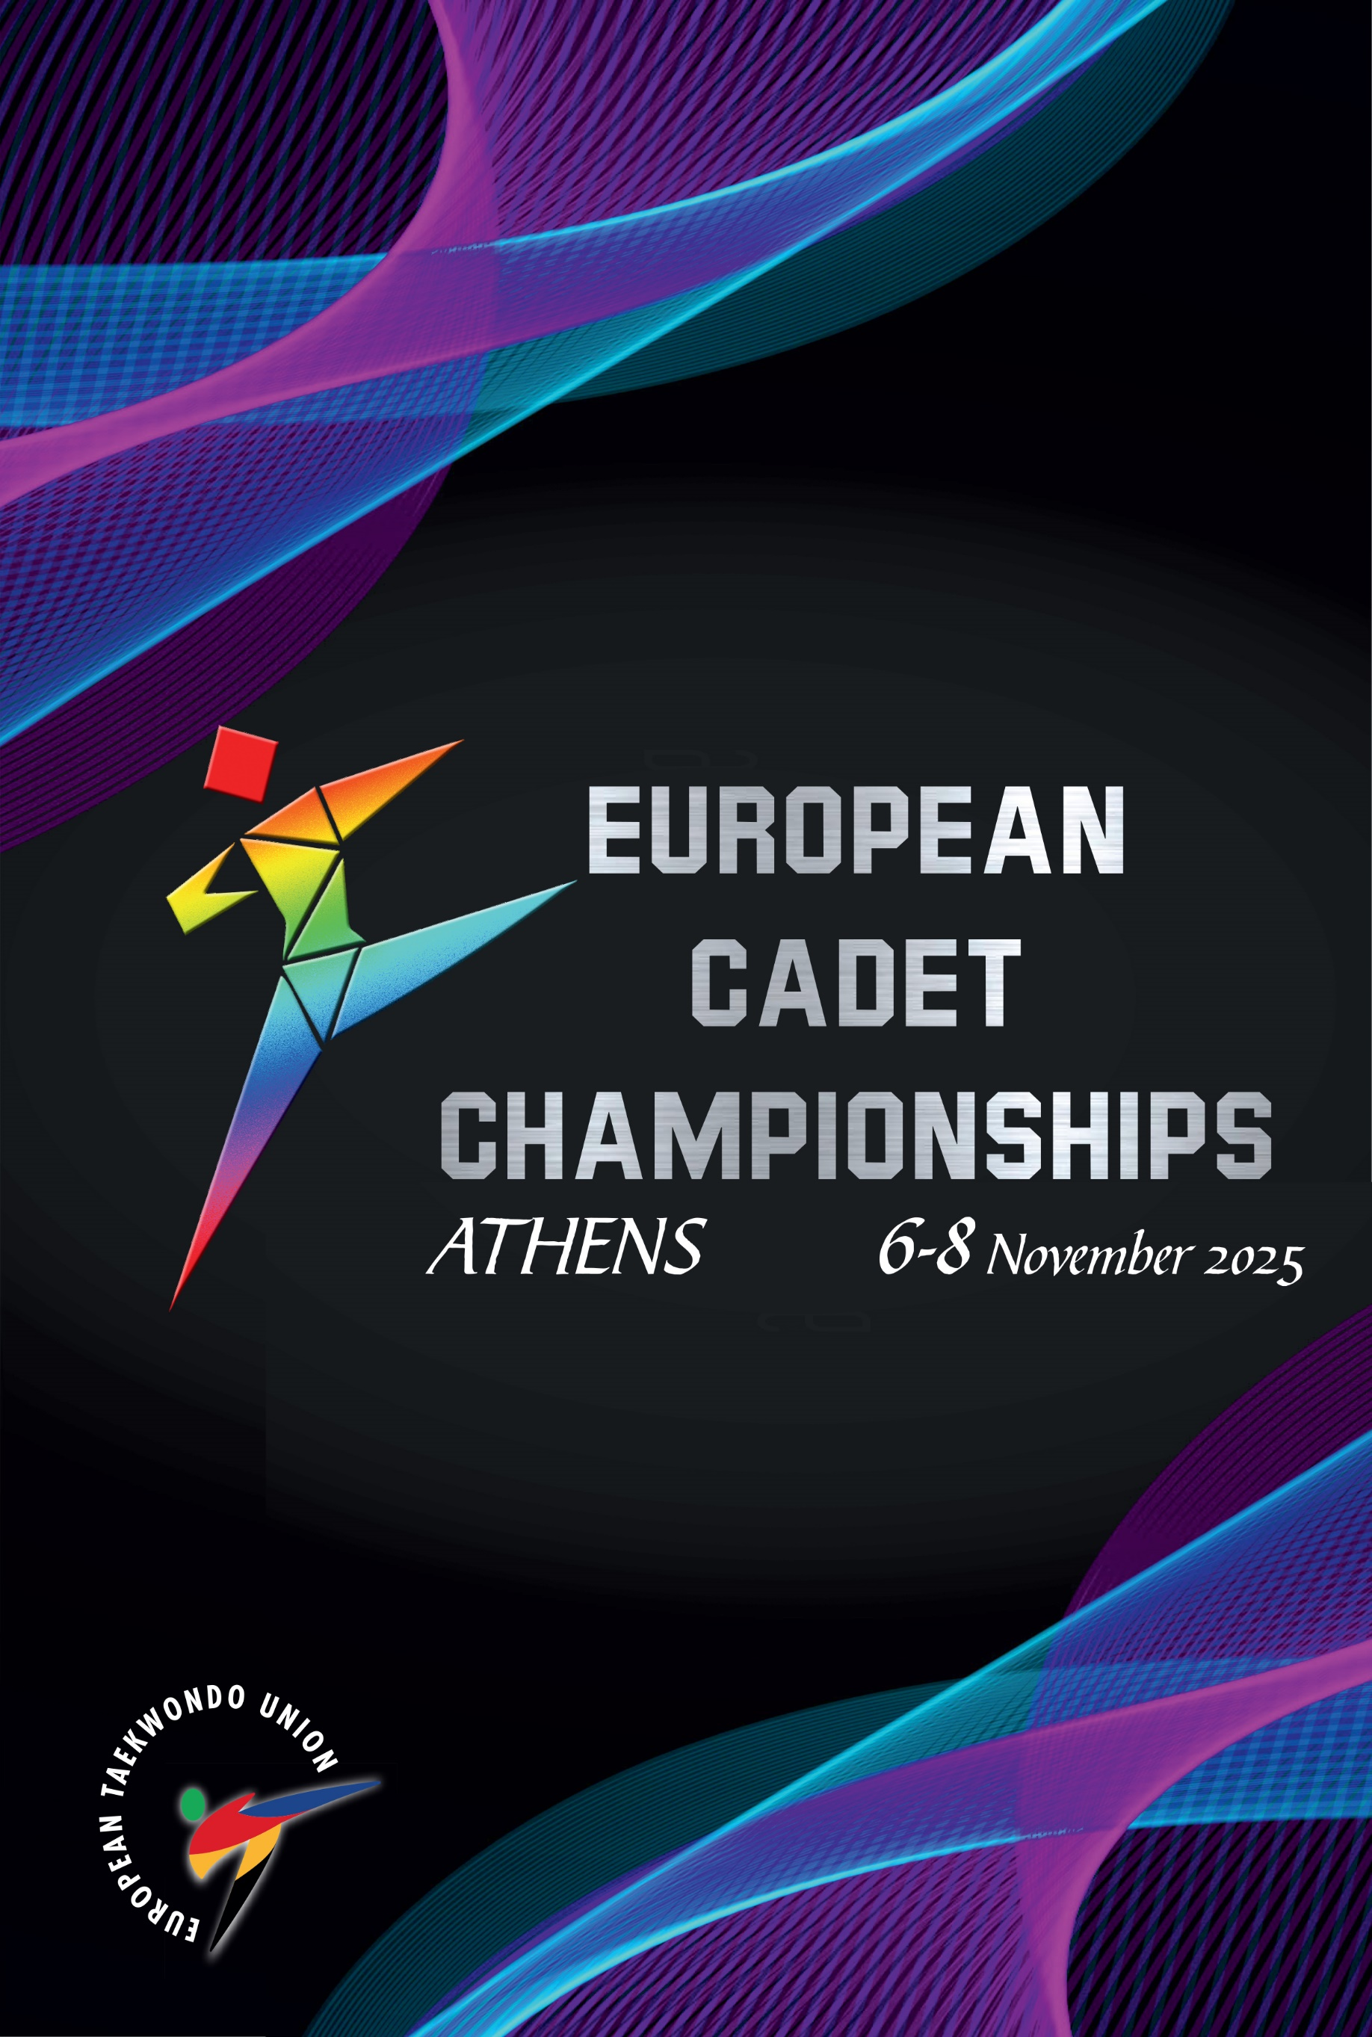
TIME TABLE(subject to change)
Date | Time | Event
Nov 4-5 |  | Arrival of Teams
Nov 4 | 15:00-18:00 | Registration
Nov 5 | 09:00-13:00 15:00-18:00 | Registration
Nov 5 | 10:00-13:00  15:00-16:00 | General Weigh-in Day 1  Male -33 kg, -37 kg, -41 kg, -45 kg, -49 kg, -53 kg,
Nov 5 | 18:00-19:00 | Head of Team Meeting / Team Doctors Meeting
Nov 5 | 19:00 | Publication Drawsheets Day 1
Nov 6 | 06:30 | Publication Random Weigh-in Day 1
Nov 6 | 08:00 | Random Weigh-in  Male -33 kg, -37 kg, -41 kg, -45 kg, -49 kg, -53 kg
Nov 6 | 09:00-13:00 15:00-18:00 | Registration
Nov 6 | 09:00-13:00 | Preliminaries & R16  Male -33 kg, -37 kg, -41 kg, -45 kg, -49 kg, -53 kg
Nov 6 | 10:00-13:00  15:00-16:00 | General Weigh-in Day 2  Female -29 kg, -33 kg, -37 kg, -41 kg, -44 kg, -47 kg, -51 kg
Nov 6 | 13:00-14:00 | Lunch Break
Nov 6 | 14:00-16:30 | QF & Semi-Finals  Male -33 kg, -37 kg, -41 kg, -45 kg, -49 kg, -53 kg
Nov 6 | 16:30-17:00 | Session Break
Nov 6 | 17:00-19:00 | Finals & Awarding  Male -33 kg, -37 kg, -41 kg, -45 kg, -49 kg, -53 kg
Nov 6 | 19:00 | Publication Drawsheets Day 2
Nov 7 | 06:30 | Publication Random Weigh-in Day 2
Nov 7 | 08:00 | Random Weigh-in  Female -29 kg, -33 kg, -37 kg, -41 kg, -44 kg, -47 kg, -51 kg
Nov 7 | 09:00-13:00 15:00-18:00 | Registration
Nov 7 | 09:00-13:00 | Preliminaries & R16  Female -29 kg, -33 kg, -37 kg, -41 kg, -44 kg, -47 kg, -51 kg
Nov 7 | 10:00-13:00  15:00-16:00 | General Weigh-in Day 3  Female -55 kg, -59 kg, +59 kg / Male -57 kg, -61 kg, -65 kg, +65 kg
Nov 7 | 13:00-14:00 | Lunch Break
Nov 7 | 14:00-16:30 | QF & Semi-Finals  Female -29 kg, -33 kg, -37 kg, -41 kg, -44 kg, -47 kg, -51 kg
Nov 7 | 16:30-17:00 | Session Break
Nov 7 | 17:00-19:00 | Finals & Awarding  Female -29 kg, -33 kg, -37 kg, -41 kg, -44 kg, -47 kg, -51 kg
Nov 7 | 19:00 | Publication Drawsheets Day 3
Nov 8 | 06:30 | Publication Random Weigh-in Day 3
Nov 8 | 08:00 | Random Weigh-in  Female -55 kg, -59 kg, +59 kg / Male -57 kg, -61 kg, -65 kg, +65 kg
Nov 8 | 09:00-13:00 | Preliminaries & R16  Female -55 kg, -59 kg, +59 kg / Male -57 kg, -61 kg, -65 kg, +65 kg
Nov 8 | 13:00-14:00 | Lunch Break
Nov 8 | 14:00-16:30 | QF & Semi-Finals  Female -55 kg, -59 kg, +59 kg / Male -57 kg, -61 kg, -65 kg, +65 kg
Nov 8 | 16:30-17:00 | Session Break
Nov 8 | 17:00-19:00 | Finals & Awarding  Female -55 kg, -59 kg, +59 kg / Male -57 kg, -61 kg, -65 kg, +65 kg
Nov 9 |  | Departure of the teams

Location: Paiania Olympic Indoor Hall
Registration, Weigh-in, Random Weigh-in, & Head of Team/Doctor Meeting
Publication: https://europetaekwondo.org/documents/
Drawsheets, Random Weigh-in, Results & General information

