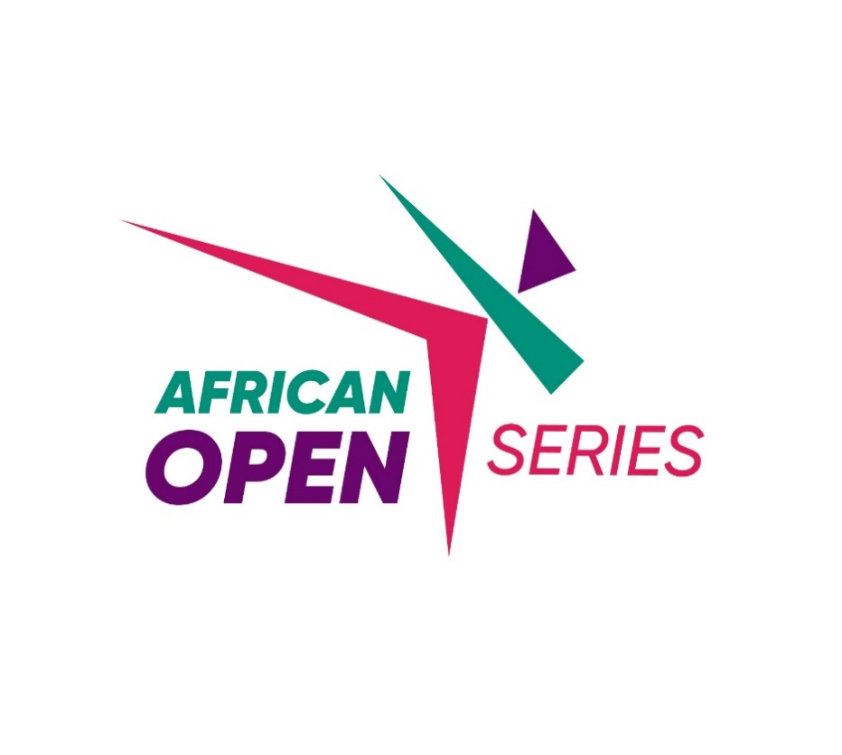

The world of Taekwondo in Africa takes a new step with the launch of the AFRICAN OPEN SERIES, a groundbreaking competition circuit aimed to increase the visibility and competitiveness of African athletes on the international stage. This initiative, created by the African Taekwondo Union (AFTU) and supported by World Taekwondo (WT), was presented at the latest AFTU general assembly in Chuncheon (Korea 2024). Adopted by all AFTU member national association, this competition promises to energize Taekwondo on the continent and open new opportunities for athletes.

Above record, Mr. Mamadou Camara NDIAYE, Technical Chairman of the African Taekwondo Union, explains the project in detail.

Mr Mamadou, What is the approach behind this project?
The AFRICAN OPEN SERIES has been designed as a touring circuit that will be held in several African countries, providing fighters of all levels with a professional space to compete. The goal is to offer a dynamic and attractive format, inspired by major global tournaments, while highlighting local talents.
.

What is the Regional Distribution Strategy for the MNAs?
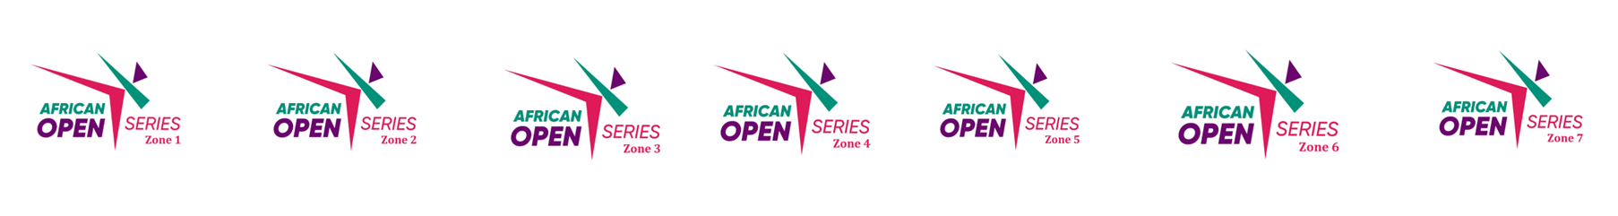
To ensure fair coverage and promote the development of Taekwondo across the continent, seven competition zones have been created. Each zone will host a major competition, providing local athletes with the chance to face off against regional opponents before competing at the continental level.
- Zone 1: North Africa with Algeria, Egypt, Morocco, Libya, Sudan, South Sudan, Tunisia
  - African Open Series 1 will be hosted by Libya on September 13th 2025
- Zone 2: West Africa (Group A) with Cape Verde, Gambia, Guinea, Guinea-Bissau, Mali, Mauritania, Senegal, Sierra Leone
  - African Open Series 2 will be hosted by Mali (Bamako) on May 20th 2025
- Zone 3: West Africa (Group B) with Benin, Burkina Faso, Ghana, Ivory Coast, Liberia, Niger, Nigeria, Togo
  - African Open Series 3 will be hosted by Mali (Bamako) on May 20th 2025
- Zone 4: Central Africa with: Cameroon, Central African Republic, Chad, Congo, Democratic Republic of Congo, Equatorial Guinea, Gabon, Sao Tome and Principe
  - Hosting country and competition date is to be determined for the African Open Series 4
- Zone 5: East Africa with: Burundi, Djibouti, Ethiopia, Kenya, Rwanda, Somalia, Tanzania, Uganda
  - African Open Series 5 will be hosted Ethiopia (Addis Abeba) on April 22nd 2025
- Zone 6: Southern Africa with Angola, Botswana, Eswatini, Lesotho, Malawi, Mozambique, Namibia, South Africa, Zambia, Zimbabwe
  - African Open Series 6 will be hosted by Mozambique (Maputo) on September 20th 2025
- Zone 7: Indian Ocean Islands with Madagascar, Mauritius, Seychelles, Comoros
  - Hosting country and competition date is to be determined for the African Open Series 7

What are the Competition Categories?
The AFRICAN OPEN SERIES will feature competitions in three main categories:
- Cadets (5 girls & 5 boys; only weight category)
- Juniors (5 girls & 5 boys)
- Seniors (8 women & 8 men)
These categories allow athletes of all ages and levels to compete in fair and age-appropriate conditions.
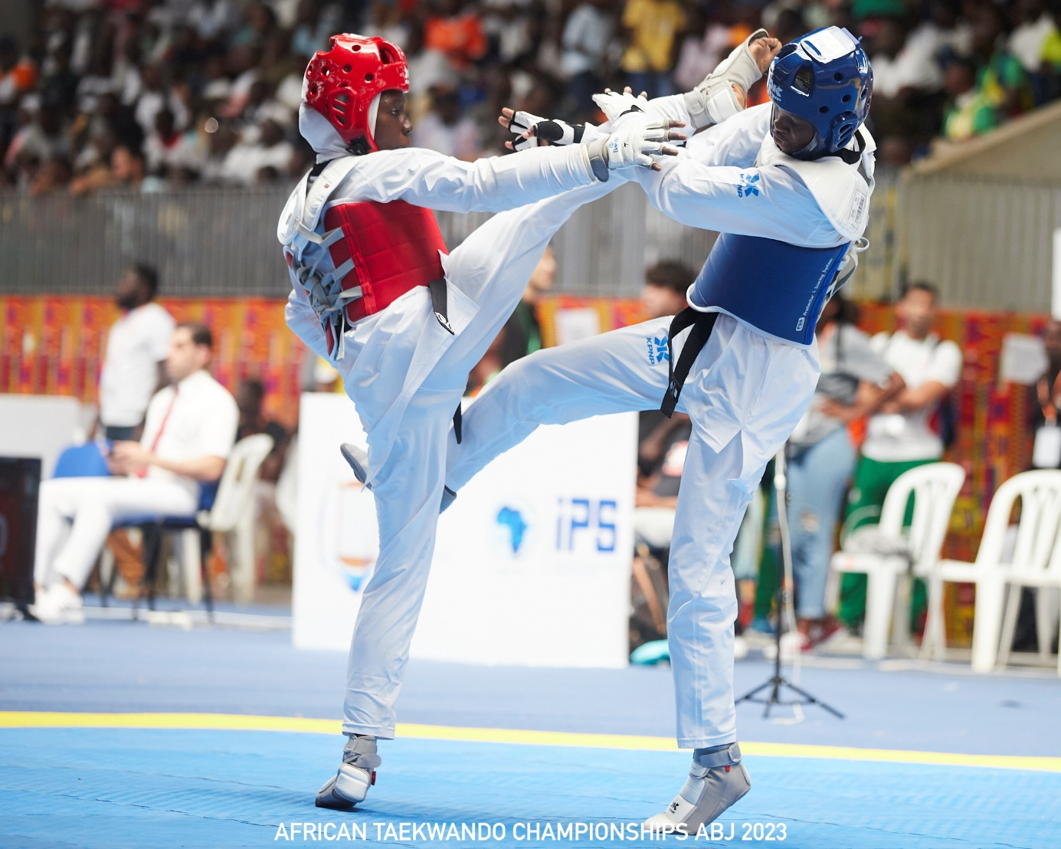

What are the participation Criterias for athletes?
Athletes wishing to participate in the AFRICAN OPEN SERIES must meet the following criteria:
- All athletes must have a valid passport of the country which they want to represent;
- All athletes must be in good standing term with their national federation (for instance, having a valid national licence is mandatory)
- The registrations are open to every single athlete in the continent, whether they are members of a national team or not, and there is no need to be recommended by a federation. This approach breaks barriers and allows for the early exposure of talent to high-level competition.
- All athletes must be at least a 1st Dan black belt for seniors. For juniors and cadets, athletes can have a red belt or higher.
- World Taekwondo global license is not mandatory (having a GAL number is highly encouraged) but as already mentioned, all athletes must be in good standing with their national federation. The African Union will listen to the federations and will not hesitate to exclude dissident athletes.
- If you are an athlete, even if you live abroad your country and outside of your zone, you can still participate in the competition (in condition to have a valid passport of your country).

What is the amount of the registration Fees?
The registration fee will be fixed by hosting countries but it is limited to 50 USD for all athletes, regardless of their geographical zone. Registration will be through exclusively on AFTU official website or any other platform designated by the AFTU. Payments of the registration fees will be made directly to the organizing committee prior the competition.

What are the Key benefits of the AFRICAN OPEN SERIES for athletes?
There are 2 majors’ benefits for athletes:
- Direct Qualification Quota for the 2026 African Championships
For seniors, the winners of each category will receive a direct qualification quota for the 2026 African Championships, regardless of their country's official delegation. This means a country could have up to 2 athletes in certain categories, increasing the chances of winning medals for the country. However, a country can qualify a maximum of 8 athletes, with 4 men and 4 women. If more than 8 athletes qualify, additional quota will be allocated to next eligible athletes from the zone, based on the final standings and merit order.

- Invitation Quota for the 2025 African Open Final
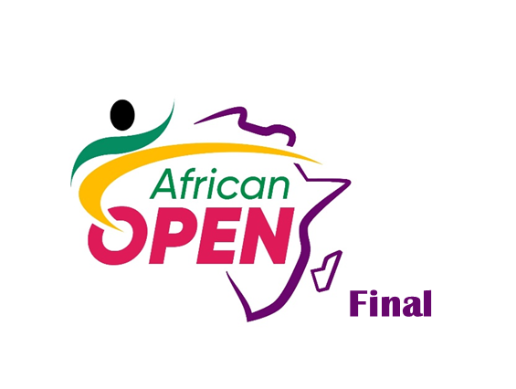
All senior and junior finalists from all African Open Series will be invited to the African Open Final, scheduled for the end of 2025 (December). At this final, winners will receive prizes, including:
- 1000 USD for gold medalists
- 500 USD for silver medalists
- 250 USD for bronze medalists
Only one (01) quota will be allocated per country. Thus, if two (02) athletes of the same nationality compete in the African Open Series final, only the winner will be qualified. The second quota will go to the next highest-ranked athlete from a different nationality.
During the African Open Final, the maximum athlete quotas for a country are 8 males and 8 females for seniors and 10 males and 10 females for juniors.
Additionally, it is important to note that the African Open Final will be granted as WT G1 event competition, allowing participants to accumulate points for the world and Olympic ranking.

Is there any other development opportunities offered by this event?
This circuit aims not only to organize competitions but also to promote the training of referees and coaches across Africa, ensuring overall skill development in Taekwondo on the continent. Before each competition, a refereeing course will be held, with coaches participating as observers. Priority will be given to referees from the zone, with a mixed approach to also encourage the participation of national referees.
The AFRICAN OPEN SERIES is part of a broader vision to make Taekwondo a vehicle for development and unity in Africa. With the support of our partners, this circuit could become an essential event for Taekwondo practitioners. The first competitions are expected in 2 months, and enthusiasm is already building among federations and athletes.

